1. Declare a single-dimensional array of 5 integers inside the main method. Traverse the array to print the default values. Then accept records from the user and print the updated values of the array.

**package** Q1;

**import** java.util.Scanner;

**public** **class** question1 {

**public** **static** **void** main(String[] args) {

**int**[] arr = **new** **int**[5];

System.***out***.println("Deafault value of array");

**for** (**int** index = 0; index < arr.length; index++) {

System.***out***.println("arr[" + index + "] =" + arr[index]);

}

Scanner sc = **new** Scanner(System.***in***);

System.***out***.println("Enter 5 integers ;");

**for** (**int** index = 0; index < arr.length; index++) {

System.***out***.println("Enter value of array[" + index + "]:");

arr[index] = sc.nextInt();

}

System.***out***.println("\nUpdated values:");

**for** (**int** index = 0; index < arr.length; index++) {

System.***out***.println("arr[" + index + "] = " + arr[index]);

}

sc.close();

}

}

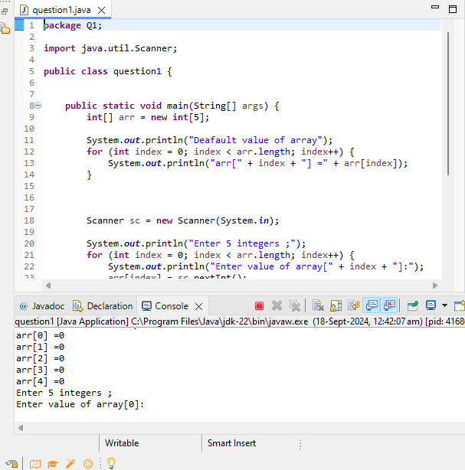

1. Declare a single-dimensional array of 5 integers inside the main method. Define a method named acceptRecord to get input from the terminal into the array and another method named printRecord to print the state of the array to the terminal.

**package** Q2;

**import** java.util.Scanner;

**public** **class** singleDimentional {

**public** **static** **void** main(String[] args) {

**int**[] arr = **new** **int**[5];

*acceptRecord*(arr);

}

**public** **static** **void** acceptRecord(**int**[] arr) {

Scanner sc = **new** Scanner(System.***in***);

System.***out***.println("Enter 5 integers:");

**for** (**int** index = 0; index <arr.length; index++) {

System.***out***.println("Enter value for arr[" + index+ "];");

arr[index] = sc.nextInt();

}

*printRecord*(arr);

}

**public** **static** **void** printRecord(**int**[] arr) {

System.***out***.println("\nValue of array:");

**for** (**int** index =0; index < arr.length; index++) {

System.***out***.println("arr[" + index + "] =" +arr[index]);

}

}

}

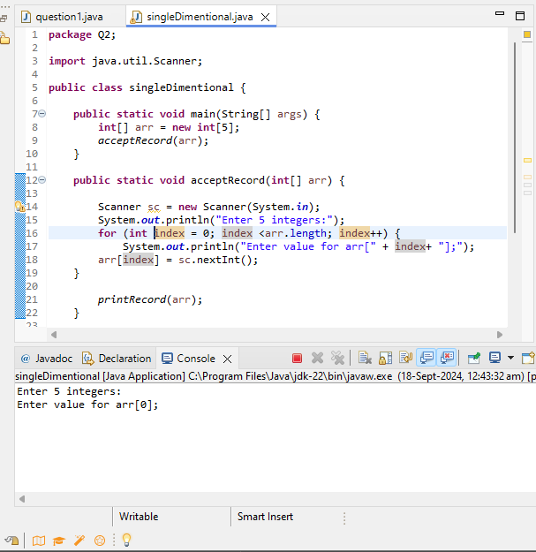

1. Write a program to find the maximum and minimum values in a single-dimensional array of integers.

**package** Q3;

**public** **class** MinimumMaximum {

**public** **static** **void** main(String[] args) {

**int**[] arr = {1,5,12,54,69,46,22,24};

*findMinMax*(arr);

}

**private** **static** **void** findMinMax(**int**[] arr) {

**int** min = arr[0];

**int** max = arr[0];

**for** (**int** i = 1; i < arr.length; i++) {

**if** (arr[i] < min) {

min = arr[i];

}

**if** (arr[i] > max) {

max = arr[i];

}

}

System.***out***.println("Minimum value: " + min);

System.***out***.println("Maximum value: " + max);

}

}

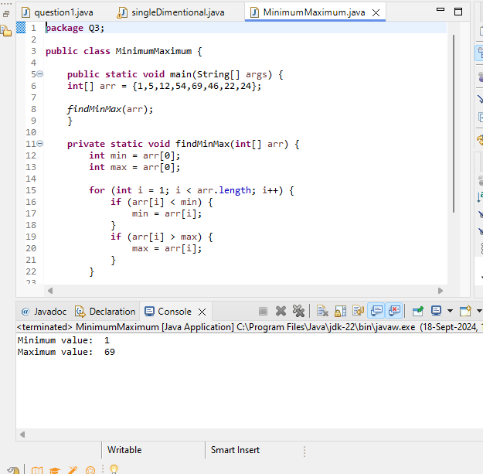

1. Write a program to remove duplicate elements from a single-dimensional array of integers.

**package** Q4;

**import** java.util.Arrays;

**public** **class** RemoveDuplicate {

**public** **static** **int**[] removeDuplicates(**int**[] array) {

Arrays.*sort*(array);

**if** (array.length <= 1) {

**return** array;

}

**int**[] temp = **new** **int**[array.length];

**int** j = 0;

temp[j++] = array[0];

**for** (**int** i = 1; i < array.length; i++) {

**if** (array[i] != array[i - 1]) {

temp[j++] = array[i];

}

}

**int**[] result = **new** **int**[j];

System.*arraycopy*(temp, 0, result, 0, j);

**return** result;

}

**public** **static** **void** main(String[] args) {

**int**[] arr = {1, 2, 3, 4, 6, 7, 8, 3, 6, 10, 12, 5, 2};

System.***out***.println("Original Array: " + Arrays.*toString*(arr));

**int**[] uniqArr = *removeDuplicates*(arr);

System.***out***.println("Array After Removing Duplicates: " + Arrays.*toString*(uniqArr));

}

}

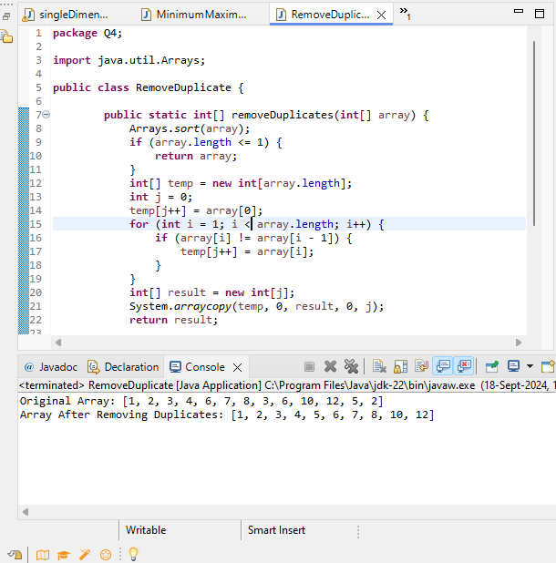

1. Write a program to find the intersection of two single-dimensional arrays.

**package** Q5;

**public** **class** ArrayIntersection {

**public** **static** **void** main(String[] args) {

**int**[] array1 = {1, 2, 3, 4};

**int**[] array2 = {3, 4, 5, 6};

**int**[] intersection = **new** **int**[Math.*min*(array1.length, array2.length)];

**int** count = 0;

**for** (**int** i = 0; i < array1.length; i++) {

**for** (**int** j = 0; j < array2.length; j++) {

**if** (array1[i] == array2[j]) {

intersection[count++] = array1[i];

**break**;

}

}

}

System.***out***.println("Intersection elements:");

**for** (**int** i = 0; i < count; i++) {

System.***out***.print(intersection[i] + " ");

}

}

}

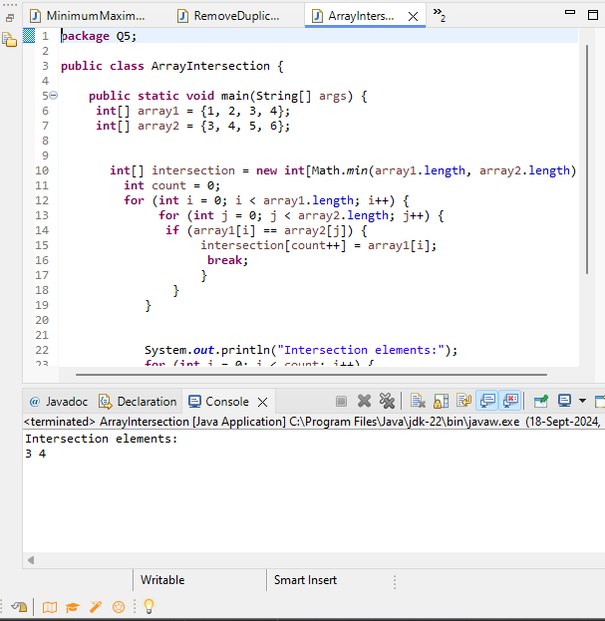

1. Write a program to find the missing number in an array of integers ranging from 1 to N.

**package** Q6;

**public** **class** MissingNum {

**public** **static** **void** main(String[] args) {

**int**[] arr = {1,2,3,4,6,7,8};

**int** missValue =0 ;

**int** j=1;

**for**(**int** i=0;i<arr.length;i++) {

**if**((arr[j]-arr[i]) != 1) {

missValue = arr[i]+1;

**break**;

}**else** {

j++;

}

}

System.***out***.println("Missing Number: "+missValue);

}

}

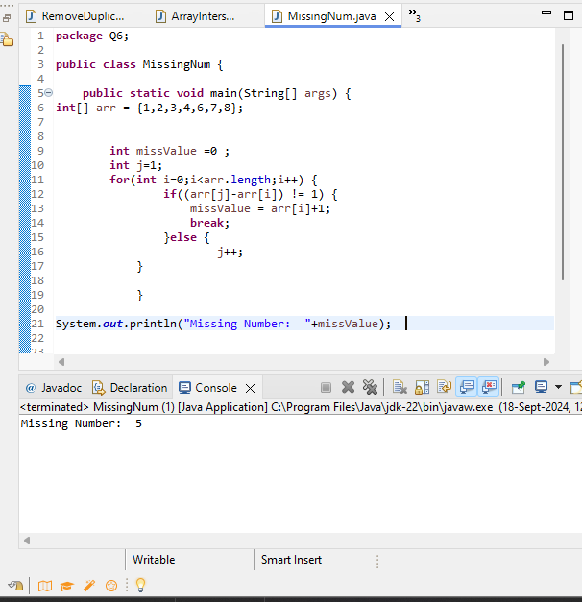

1. Declare a single-dimensional array as a field inside a class and instantiate it inside the class constructor. Define methods named acceptRecord and printRecord within the class and test their functionality.
2. Modify the previous assignment to use getter and setter methods instead of acceptRecord and printRecord.
3. You need to implement a system to manage airplane seat assignments. The airplane has seats arranged in rows and columns. Implement functionalities to:

* Initialize the seating arrangement with a given number of rows and columns.
* Book a seat to mark it as occupied.
* Cancel a booking to mark a seat as available.
* Check seat availability to determine if a specific seat is available.
* Display the current seating chart.